
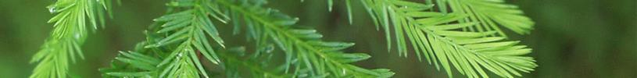
eligibl

NOTICE OF

FUNDING OPPORTUNITY

STATE, PRIVATE, & TRIBAL FORESTRY
Great Lakes Restoration Initiative: Community Forest and Open Space Conservation Program

July 2026
Contents
I. BASIC INFORMATION 3
II. APPLICANT ELIGIBILITY 4
III. PROGRAM DESCRIPTION 5
IV. APPLICATION CONTENTS AND FORMAT 8
V. SUBMISSION REQUIREMENTS AND DEADLINES 12
VI. APPLICATION REVIEW 14
VII. AWARD NOTICES 17
VIII. POST-AWARD REQUIREMENTS AND ADMINISTRATION 18
IX. OTHER INFORMATION 19
Appendix A. Terrestrial Habitat Connectivity Pilot Area 21
Appendix B. Cover Page Template 23
Appendix C. Sample Budget Tables 24

I. BASIC INFORMATION
The Forest Service is a federal agency under the U.S. Department of Agriculture (USDA) that manages 193 million acres of National Forest System land. The agency also provides technical and financial assistance to over 140 million acres of state, private and tribal lands, and makes up the largest forestry research organization in the world. The Forest Service helps people share and enjoy forests while conserving the environment for generations to come.
The mission of the Forest Service is to sustain the health, diversity, and productivity of all the Nation’s forests and grasslands to meet the needs of present and future generations. The Forest Service motto, “Caring for the Land and Serving People,” captures the spirit of our mission, which we accomplish through these main activities:
- Protection and management of natural resources on lands we manage
- Research on all aspects of forestry, rangeland management, and forest resource utilization
- Community assistance and cooperation with State and local governments, forest industries, and private landowners to help protect and manage non-Federal forest and associated range and watershed lands to improve conditions in rural areas
- International assistance to formulate policy and coordinate U.S. support for the protection and sound management of the world's forest resources
Executive Summary
The interagency Great Lakes Restoration Initiative (GLRI) targets improvements to address the most significant environmental problems within the Great Lakes Basin. Through an agreement with the Environmental Protection Agency (EPA), the United States Department of Agriculture (USDA) Forest Service receives funds for competitive grant programs. This program supports projects that implement strategic, priority actions within USDA Forest Service authorities to restore, protect, and maintain the Great Lakes ecosystems.
For the GLRI Community Forest and Open Space Conservation Program (CFP) competitive grant program, Indian Tribes, local governments, and qualified conservation non-profit organizations are provided with federal financial assistance to acquire full ownership of private forest land within the Terrestrial Habitat Connectivity Pilot Area in Wisconsin and Michigan (Appendix A) that provides identified community benefits.
The purpose of the CFP is to establish community forests by protecting forestland from conversion to non-forest uses and provide community benefits including public recreation, environmental and economic benefits, and forest-based educational programs. Community engagement in the establishment and long-term management of the forest is a core element of the program. Public access is required for all projects. GLRI CFP projects must also support the objective defined by GLRI Action Plan IV’s Focus Area 4.1, which is to “protect, enhance, and increase resilience of habitats necessary for sustaining native aquatic and terrestrial species important to the Great Lakes ecosystem.” Final awards may be adjusted based on proposed scope, project activities, and funding availability.

- Funding Opportunity Title: Great Lakes Restoration Initiative: Community Forest and Open Space Conservation Program
- Announcement Type: Initial Announcement
- Funding Opportunity Number: USDA-FS-2026-GLRI-CFP
- Assistance Listing Number(s): 10.689 – Community Forest and Open Space Conservation Program
- Funding:
  - Estimated Total Program Funding: $3,500,000
  - Expected Number of Awards: 4-6 awards estimated, to be determined by individual award funding requests and the number of competitive applications received.
  - Individual Award Funding: Up to $1,000,000 for eligible land acquisition and transactional costs. The Agency reserves the right to award an applicant less than the funding requested based on funding availability and project eligibility.
- Key Dates:
  - Application Due Date: 11:59PM Eastern Time on December 8, 2026.
    - Submit applications on Grants.gov under Funding Opportunity Number USDA-FS-2026-GLRI-CFP
    - USDA Forest Service staff will forward project applications to the State Forester of the state where the project is located for their awareness.
  - Anticipated Award Date: Spring 2027
  - Expected Time to Process Application and Notify Applicant: 2-4 months
- Agency Contact Information: Applicants are encouraged to work with USDA Forest Service staff before application submission. Questions may be directed to Liam Krause, Acting Regional Program Manager (liam.krause@usda.gov).
- New Program, One-Time Initiative, or Annual Grant Announcements associated with existing program: Annual Grant Announcement

II. APPLICANT ELIGIBILITY
- Eligible Applicants
- Entity Types: Eligible entities are described in 36 CFR 230.2 and include:
- Federally recognized Indian Tribes
- Local government entities
- Nonprofit organizations that are qualified to acquire and manage land
- Disqualifying Criteria:
    - Applicants that do not meet eligibility criteria will be deemed ineligible and removed from competition without further consideration.
- Funding Restrictions Affecting Eligibility:
    - A proposed project cannot be submitted for funding consideration simultaneously for both the GLRI CFP and the Forest Legacy Program.
    - Inability to meet the cost share requirement of 50%.
- Factors Disqualifying an Application: Applications submitted without an active SAM.gov registration and/or without the required 50% cost share will not be considered.
- Limit on Allowable Application Submissions: There are no limits on the number of applications an applicant may submit to this opportunity or the number of awards an applicant can receive.
- Cost Sharing
- Required Cost Sharing: Cost sharing is required for all applications.
- Cost Sharing Calculations: All applicants must demonstrate a 50 percent cost share of the total project cost. The cost share can include cash, in-kind services, or donations from a non-Federal source.
- Cost Sharing Restrictions: A non-Federal entity’s in-kind match must meet the following criteria:
  - Not included as contributions for any other Federal award
  - Necessary and reasonable for accomplishment of project or program objectives
  - Not paid by the Federal Government under another Federal award, except where the Federal statute authorizing a program specifically provides that Federal funds made available for such program can be applied to matching or cost sharing requirements of other Federal programs
  - Conform to other provisions of 2 CFR 200, including being allowable under subpart E.
- Cost Sharing Commitment Requirements: Cost share contributions must be verifiable from the non-Federal entity’s records.

III. PROGRAM DESCRIPTION
- Funding Purpose: Grant awards will support the fee simple acquisition of private forest land within the Terrestrial Habitat Connectivity Pilot Area (Appendix A) that is threatened by conversion to non-forest uses and that provides community benefits including economic, environmental, educational, and recreational benefits. The purpose of the GLRI CFP funding is further focused on the stated objective of the GLRI Action Plan IV’s Focus Area 4.1, which is to “protect, enhance and increase resilience of habitats necessary for sustaining native aquatic and terrestrial species important to the Great Lakes ecosystem.”
Habitat connectivity is important to sustain biological variation of native plants and animals. Connected landscapes allow for the movement of species, facilitate ecological processes, and allow animals to adapt to changing conditions. Connectivity includes both structural (physical relationship between habitat patches) and functional (degree to which landscapes facilitate or impede the movement of organisms and process) components. The Terrestrial Habitat Connectivity Pilot Area (Appendix A) was selected because of the considerable natural habitat in this region of the Upper Great Lakes, and because it is an area where habitat improvement would rapidly increase connectivity benefits for wildlife.
- Funding Priorities: Priority will be given to applications that:
  - Provide exceptional community benefits (economic, environmental, educational, recreational) that are specific to the lands to be acquired, planned for, and supported by data, evidence, and/or local knowledge.
  - Demonstrate meaningful and broad community engagement through the planning and long-term management of the project.
  - Provide strategic contributions and connection to broader landscape initiatives.
  - Are exceptionally threatened by conversion to non-forest uses.
  - Support functional habitat connectivity in the Terrestrial Habitat Connectivity Pilot Area. Prioritized projects will be those that improve functional habitat connectivity, which could include increasing the width of wildlife corridors, increasing the number of corridors, or reducing corridor pinch points (locations in corridors where movement is restricted).
  - Conserve large and complex components of the Terrestrial Habitat Connectivity Pilot Area, address native ecosystems and species considered high priority by multiple agencies and stakeholders, and are part of a long-term or larger-scoped plan intended to improve functional connectivity across a significant portion of the target area.
- Program Goals and Objectives: The GLRI CFP provides competitive grant awards to eligible entities to acquire and establish community forests through fee simple acquisition of private forest land with the goal of improving functional wildlife habitat connectivity within the Terrestrial Habitat Connectivity Pilot Area.
- Award Goals and Objectives: Funded projects will permanently conserve private forestland for the benefit of the public, including public access, habitat connectivity, and other benefits.
- Expected Achievements: GLRI CFP projects result in the acquisition and establishment of community forests which provide defined community benefits, with the priority being focused on achievements that improve functional wildlife habitat connectivity. Awarded projects are expected to achieve the following outcomes:
  - Permanent conservation of forestland that supports community, cultural, ecological, and economic benefits.
  - Measurable improvements in habitat connectivity contributing to the long‑term resilience of native species.
  - Increased community involvement in forest management and stewardship.
  - Enhanced public recreation, education, and ecosystem services, consistent with program goals.
  - Contribution to GLRI Action Plan IV objectives through habitat protection within a high‑priority geography.
- Eligible Land: Land eligible for funding consideration through this opportunity is private forest land that will provide community benefits and is:
  - At least five acres in size, suitable to sustain natural vegetation;
  - At least 75 percent forested;
  - Threatened by conversion to non-forest uses;
  - Not held in trust by the United States on behalf of any Indian Tribe and not Tribal allotment lands;
  - Offered for sale by a willing seller; and
  - At least 75 percent of the proposed tract of land must be located within the Terrestrial Habitat Connectivity Pilot Area in Wisconsin and Michigan (Appendix A).
- Allowable Costs: Allowable project costs include the purchase price for the property as well as transactional costs related to its acquisition. This includes:
  - Appraisals and appraisal reviews
  - Land surveys
  - Legal and closing costs
  - Development of the Community Forest Plan
  - Title examination
Note: Costs must conform to 2 CFR 200.
- Unallowable Costs: Project costs cannot include:
  - Long-term operations, maintenance, and management of the land
  - Construction of buildings or recreational facilities
  - Research
  - Existing liens or taxes owed
  - Unmanned Aircraft Systems (UAS)
  - Indirect costs
  - Costs associated with preparing this application (except for any of the allowable project costs specified above)
- Beneficiaries or Program Participants Eligibility: There are no specific eligibility criteria for beneficiaries or program participants other than Federal award recipients.
- Program Citations: Grants awarded under this announcement must conform to laws and authorities in Section 7A of the Cooperative Forestry Assistance Act ([16 U.S.C. 2103d] Community Forest and Open Space Conservation Program) as amended.
OTHER INFORMATION
- Examples of Previously Successful Projects: Examples of previously successful projects can be found on the Community Forest Program website.
- Grant Award Time Frame: The initial grant period shall be for two years, and acquisition of lands should occur within that timeframe. Lands acquired prior to the grant award are not eligible for Community Forest Program funding. The grant may be reasonably extended by the Forest Service when necessary to accommodate unforeseen circumstances in the land acquisition process.

IV. APPLICATION CONTENTS AND FORMAT
- Required Contents: The following documents must be submitted through Grants.gov under Funding Opportunity Number USDA-FS-2026-GLRI-CFP:
  - Project cover page (see Appendix B for an example that includes the required elements)
  - Application Narrative (8 pages maximum): The Application Narrative should clearly describe the land to be acquired with CFP funds. If the proposed project is an expansion of existing conserved lands (including a phase or addition to an existing community forest) or part of a larger land acquisition effort occurring at the site, the application should be specific to the community forest portion of the effort proposed for funding. The following information must be included in the Application Narrative:
    - Contact information for the project lead (name, title, phone number, email).
    - A description of how the land proposed for acquisition meets the program’s eligibility requirements as defined in Section III, Eligible Land.
    - Detailed information about the property proposed for acquisition:
      - A description of the property, including acreage and county location.
      - A description of current land uses, including improvements and plans for utilization or demolition of existing structures.
      - A description of forest type and vegetative cover.
      - A description of applicable zoning and other land use regulations affecting the property.
    - A description of the type and the extent of community benefits that the property will provide in the following categories. Applicants must provide quantifiable information, when available, to demonstrate the scale and significance of these benefits:
      - Economic benefits, such as timber and non-timber products resulting from sustainable forest management, recreation, and tourism. Applicants should include projected annual timber harvest volumes, anticipated non‑timber forest product yields, estimated jobs supported by forest management or recreation, and projected recreation‑driven economic impacts, such as expected visitor‑related revenue.
      - Environmental benefits, including clean air and water, stormwater management/flood mitigation, wildlife habitat, and cultural resources. Applicants should quantify environmental outcomes where possible, including acres contributing to improved water quality, linear feet of protected waterways, acres providing stormwater or flood‑mitigation benefits, and acres of wildlife habitat protected or enhanced.
      - Recreational benefits, such as hiking, hunting, and fishing secured through public access. Applicants should provide estimated annual visitor use, anticipated trail or facility use counts, or projected participation levels in hunting, fishing, paddling, mountain biking, hiking, or other outdoor activities enabled by the project.
      - Educational benefits from forest-based experiential learning, including K-12 conservation education programs, vocational education programs in disciplines such as forestry and environmental biology, environmental education through participation in programs offered by organizations; and replicable models of effective forest stewardship for private landowners. Applicants should include estimated annual participant numbers, planned program hours, anticipated school or partner involvement, or expected landowner engagement counts for stewardship demonstrations.
    - Description of the planned public access and any limitations to public access on the property. Public access is required for all Community Forest Program projects. If limitations to public access exist or will be proposed to protect cultural or natural resources, or public health and safety, provide an explanation.
    - A description of how the property fits within and contributes to specific landscape conservation initiatives.
    - A description of the relationship of the property’s contributions to improving functional habitat connectivity within the Terrestrial Habitat Connectivity Pilot Area in Wisconsin and Michigan (Appendix A).
    - A description of any threats of conversion to non-forest uses, including any encumbrances on the property that prevent conversion to non-forest uses.
    - The objectives of the community forest. For example, objectives might relate to addressing natural resource concerns, wildlife habitat, recreation, public access, or other elements.
    - A description of the benefiting community, including:
      - Demographics.
      - Availability and access to green spaces.
      - A description of how the project benefits the community and the associated benefits.
    - A description of community engagement in the proposed community forest acquisition. Identify the engagement that has occurred, what is planned, who has been engaged, and strategies used to engage the community.
    - Identify the people and organizations that support the project, describe their specific role in acquiring the land and establishing and managing the community forest.
    - A description of the resources that will be used to maintain and manage the property as a community forest in perpetuity.
    - A proposed project budget not exceeding $1,000,000 in Federal costs. See Appendix C for sample budget table.
    - The status of due diligence, including signed option or purchase and sale agreement, title search, minerals determination, and appraisal.
    - Description and status of cost share (secure, pending, commitment letter, etc.).
    - The status of negotiations with participating landowner(s), including purchase options, contracts, and other terms and conditions of sale.
    - The proposed timeline for completing the acquisition and establishing the community forest.
    - Long term management costs and funding source(s).
  - Two maps displaying the project area.
    - The maps must be of sufficient scale showing the location of the property in relation to roads and other improvements as well as parks, refuges, or other protected lands in the vicinity.
  - Eligibility verification
    - Applicant Eligibility: A written description or documentation verifying that the applicant is an eligible entity must be submitted with the application. Eligible Entities include local governmental entities, federally recognized Indian Tribes, and qualified nonprofit organizations.
    - Federal Lands Verification: A letter of concurrence is required from the federal land manager if the property is located within the designated boundary of a federal land management unit. Reach out to Liam Krause, Acting Regional Program Manager (liam.krause@usda.gov) if you are unsure if the property is located within the boundary of a federal land management unit or how to secure the letter.
  - SF-424, Application for Federal Assistance
Letters of support may accompany the application but are not required.
- Requirements After Notification of Intent: The Forest Service may have responsibility to comply with the National Environmental Policy Act (NEPA) of 1969, 42 U.S.C. § 4321 et seq., and the USDA NEPA regulations at 7 CFR part 1b. If NEPA review is required, the awardee may not initiate any activity under this federal award (except NEPA support activities) until any NEPA review, if required, has been completed and documented by the Forest Service.
- Formatting Requirements: The Application Narrative, including the project budget, should use a standard typeface with no smaller than 12-point font and 0.5 inch margins, and shall not exceed eight pages (sized at 8.5 by 11 inches). Each map should fit within a single 8.5” x 11” page. Applications must comply with 2 CFR 200.

V. SUBMISSION REQUIREMENTS AND DEADLINES
Address to Request Application Package
- Application Materials: Application materials can be accessed at Grants.gov. Click on the “Search Grants” tab and enter the Funding Opportunity number or Assistance Listing number and click the search button.
  - Funding Opportunity Number: USDA-FS-2026-GLRI-CFP
  - Assistance Listing: 10.689
Unique Entity Identifier and System for Award Management (SAM.gov).
- Each Entity Applicant Must:
- Register in SAM.gov before applying
- Provide the valid unique entity identifier (UEI) from SAM.gov
- Maintain an active SAM.gov registration with current information at all times during which there is an active Federal award, or an application or plan is under consideration by a Federal agency.
Grants.gov registration
- After obtaining the UEI through the SAM.gov registration, your organization must register with Grants.gov following the instructions found at the Applicant Registration page on Grants.gov.
Submission Instructions
- Actions Prior to Applying: Applicants are strongly encouraged to contact and work with a Forest Service representative during the application process and before submission. Forest Service staff can assist with navigating program requirements, determining eligibility, providing guidance on allowable costs and cost-sharing, and other questions. Questions may be directed to Liam Krause, Acting Regional Program Manager (liam.krause@usda.gov).
Applicants are also encouraged to consult with their appropriate State forestry agency, Tribal administrator (for federally recognized Tribes), or federal land manager (for work abutting the boundaries of a designated federal management unit) to develop and submit applications and research how their project fits into the goals and objectives of the State Forest Action Plan, State Wildlife Action Plan, and other landscape level management priorities. Not contacting a Forest Service representative has no bearing on the consideration or success of an application.
To assist applicants, the following resources are available on the Community Forest Program website: a Community Forest Road Map, map recommendations, and more. The Community Forest Program website is located at: https://www.fs.usda.gov/managing-land/private-land/community-forest/program.
- Application Submission Methods: Submit all applications for this GLRI CFP funding opportunity through Grants.gov under Funding Opportunity Number USDA-FS-2026-GLRI-CFP. Project applications not received through Grants.gov will not be considered for this funding opportunity.
- Other Required Documents: N/A
- Submission Alternatives: Contact Liam Krause, Acting Regional Program Manager (liam.krause@usda.gov) if you encounter any difficulties with submitting your application.
Submission Dates and Times
- Full Application Deadline: Eligible applicants must submit all application materials through Grants.gov under Funding Opportunity Number USDA-FS-2026-GLRI-CFP no later than 11:59PM Eastern Time on December 8, 2026.
  - Note: USDA Forest Service staff will forward project applications to the State Forester of the state where the project is located for their awareness.
Intergovernmental Review
- Intergovernmental Review of Federal Programs: This funding opportunity is not subject to Executive Order 12372, “Intergovernmental Review of Federal Programs”.

VI. APPLICATION REVIEW
Responsiveness Review
- Responsiveness Review Process: All submissions will be screened for completion, adherence to application requirements, alignment with program goals, and compliance with USDA Forest Service policies before advancing in the review process. Incomplete submissions will disqualify an application from consideration. Late proposals and proposals that are faxed or mailed will not be accepted.
- Disqualifying Criteria: Applications will be reviewed for disqualifying factors that include:
  - Ineligible land
  - Ineligible applicants
  - Incomplete application submissions
  - Lack of public access
  - Inactive Sam.gov registration
  - Inadequate cost-share
  - Unallowable costs
- Restrictions: Eligible entities and eligible lands are defined in 36 CFR 230.2. Additionally, at least 75 percent of the proposed tract of land must be located within the Terrestrial Habitat Connectivity Pilot Area in Wisconsin and Michigan (Appendix A).
Review Criteria
- Criteria: Applications will be evaluated and assigned scores out of a maximum of 40 points based on the criteria described below. Projects must be designed to close within two years of the grant award, and reviewers will consider whether the applicant has demonstrated the capacity, readiness, and due diligence necessary to complete all required acquisition and establishment activities within this two‑year performance period. At a minimum, funded projects are expected to: complete all real estate due diligence; acquire the property in fee simple; ensure public access; initiate community engagement for long‑term management; and begin development of the Community Forest Plan.
  - Type and extent of community benefits provided (up to 20 points)
    - Economic benefits, such as timber and non-timber products resulting from sustainable forest management, recreation and tourism.
    - Environmental benefits, including clean air and water, stormwater management/flood mitigation, wildlife habitat, and cultural resources
    - Benefits from forest-based experiential learning, including K-12 conservation education programs; vocational education programs in disciplines such as forestry and environmental biology; and environmental education through individual study or voluntary participation in programs offered by organizations
    - Benefits from serving as replicable models of effective forest stewardship for private landowners
    - Recreational benefits such as hiking, hunting, and fishing secured through public access
    - Habitat connectivity benefits, which could include increasing the width of wildlife corridors, increasing the number of corridors, or reducing corridor pinch points (locations in corridors where movement is restricted).
  - Community Engagement (up to 10 points). Reviewers will assess the extent and nature of community engagement in the planning, development, and long-term management of the community forest, including demonstrated support, partnerships, and public participation.
  - Strategic Contribution and Connection (up to 5 points). Extent to which the community forest contributes to any landscape conservation initiatives.
  - Threat (up to 5 points). Likelihood that, unprotected, the property would be converted to non-forest uses.
- Statutory, Regulatory, or Other Preferences: Other factors that will be considered by the review panel include:
  - The Forest Service will give additional consideration to applications that support the development of domestically sourced timber and wood products, in support of Executive Order 14225, Immediate Expansion of American Timber Production.
  - Reviewers will also consider the extent of due diligence completed on the project to date, including the status of appraisal and other due diligence costs.
- Cost Sharing: Cost sharing in an amount that is at least equal to the amount of the grant received is an eligibility criterion for this opportunity per 16 U.S.C. § 2103(c)(2) and (3).
Application Reviewers
- Reviewers: USDA Forest Service personnel, including CFP program managers. Reviewers may also include other Forest Service personnel with backgrounds and expertise in areas relevant to the program (e.g. lands, forestry, community engagement).
- Reviewer Process: To ensure the application review process is transparent and fair, the Forest Service will establish a review panel consisting of Forest Service representatives. Representatives are primarily CFP program managers who have familiarity with program requirements and land acquisitions. Applications will be reviewed and evaluated by the review panel based on the criteria identified in the Review Criteria section above.
Review and Selection Process
  - Selection Measures: USDA Forest Service personnel engaged in the application review process will take into consideration the Review Criteria section above and an applicant’s capacity to close a project within two years of the grant award.
  - Merit Review Process: Funding selection will be made based on a project’s alignment with the Review Criteria section above.
Final Selection Process
- Selection Official(s): The Office of the Chief of the USDA Forest Service will provide final approval of the project list recommended by the review panel.
- Multi-phase review methods: N/A
Risk Review
- Risk Review Factors: Before any grants are awarded, the USDA Forest Service will conduct a risk review considering the grantee’s financial stability, history of performance, audit reports and findings, and ability to implement the project and meet grant requirements.
- Award Exceeds Simplified Acquisition Threshold:
- Prior to awarding a total amount of Federal share greater than the simplified acquisition threshold of $350,000, the Federal agency must review and consider any applicant information in the responsibility/qualification records available in SAM.gov (see 41 U.S.C. 2313).
- An applicant can review and comment on any information in the responsibility/qualification records available in SAM.gov.
- Before making decisions in the risk review, the Federal agency will consider any applicant comments and information available in the responsibility/qualification records in SAM.gov.

VII. AWARD NOTICES
- Award Notification: The USDA Forest Service will notify selected applicants via email. After the notification, the Forest Service will begin working with successful applicants on required grant award forms to finalize an award agreement. The notification of project selection is not an authorization to begin project performance. The executed Federal award is the authorizing document.
- Pre-Award Costs: For purposes of calculating the cost share contribution, the grant recipient may request inclusion of project due diligence costs, such as title review and appraisals, incurred prior to issuance of the grant. These pre-award costs may have been incurred up to one year prior to the issuance of the grant but cannot include the purchase of Community Forest Program land, including cost share tracts.
- Federal Award:
  - Once an application is selected, the applicant must work with the Forest Service to successfully execute a grant award agreement to receive funding.
  - The notice of Federal award signed by the Forest Service Signatory Official, or equivalent, is the official document that allows for funds to be obligated into the agreement. This document will be provided to the applicant by email.
  - Forest Service must approve any amendments to an application or request to reallocate funding within a grant application. If negotiations on a selected project fail, the applicant cannot substitute an alternative site.
- Notifications to Applicants Not Awarded: The USDA Forest Service will notify unsuccessful applicants via email shortly after successful applicants have been notified. The notification will include contact information for a Forest Service staff member who may be contacted if the applicant would like further information about their application and/or selection process.

VIII. POST-AWARD REQUIREMENTS AND ADMINISTRATION
- Administrative and National Policy Requirements. The grant recipient must adhere to the Uniform Administrative Requirements, Cost Principles, and Audit Requirements for Federal Awards also referred to as the Omni Circular (2 CFR part 200).
- General Terms and Conditions: All agreements will be subject to the USDA General Terms and Conditions and the Forest Service General Terms and Conditions.
  - Specific Terms and Conditions: Specific program terms and conditions will be provided at the time of award, in alignment with Section 7A of the Cooperative Forestry Assistance Act of 1978 (U.S.C. 2103d).
  - Special Requirements:
Within 120 days of the land acquisition, grant recipients will be required to provide the Forest Service with the following documents:
    - Geographic Information System (GIS) shapefile: a digital, vector-based storage format for storing geometric location and associated attribute information of Community Forest Program project tracts and cost share tracts, if applicable
    - Final Community Forest Plan
Under 2 CFR 415.2, recipients are required to include an acknowledgment of USDA awarding agency support on any information dissemination products produced with federal financial assistance, including those that report or describe a federally supported activity, which includes all media, press, signage, and other documents related to the creation of the community forest. .
  - Reporting:
- Reporting Type: Financial and performance
  - Required Annual Performance Metrics:
    - Acres of private forestland permanently conserved, including cost‑share tracts where applicable.
    - Timber and non‑timber forest products produced, reported in measurable units such as board feet, tons, or other commodity‑specific metrics.
    - Estimated number of jobs supported by active forest management, timber utilization, or recreation use of the community forest.
    - Recreation and public access metrics, such as estimated visitor use numbers, participation levels in major recreational activities, or trail use counts if available.
    - Documented economic benefits, including any measurable indicators of recreation‑driven revenue or local business impacts associated with the project.
    - Habitat connectivity measures, including acres contributing to corridor function, improvements made to connectivity, or changes observed in corridor width, number of connectors, or reduction in corridor pinch points.
    - Ecological outcomes, such as acres contributing to water quality protection, wildlife habitat improvements, or other environmental indicators relevant to the project area.
    - Community engagement metrics, including numbers of participants in planning meetings, stewardship activities, or educational and volunteer events connected to long‑term management of the forest.
- Reporting Frequency: At a minimum annually, with award letter articulating required frequency.
- Reporting Submission: Electronic
- References: 2 CFR 180.335 and 2 CFR 180.350
- Awards Exceeding $500,000: If the Federal share of the award exceeds $500,000 over the period of performance, there are additional post-award reporting requirements, as outlined in 2 CFR 200 Appendix XII.

IX. OTHER INFORMATION
- Resources
- SAM.gov information
- SAM.gov new registration: https://sam.gov/entity-registration
- SAM entity registration video: https://www.youtube.com/watch?v=ZJju__0bNCY&t=63s
- For assistance with SAM registration, contact an APEX Accelerator organization near you: https://www.apexaccelerators.us
- Grants.gov
  - Quick Start Guide for Applicants: https://www.grants.gov/quick-start-guide/applicants
  - Grants.gov Applicant Registration Page: https://www.grants.gov/applicants/applicant-registration
- USDA Forest Service Community Forest Program Website: Home to many resources for applicants, including:
  - Community Forest Program Roadmap: Provides an overview of the Community Forest Program, including information about eligibility and the application process.
  - Map recommendations and examples: Guidance for applicants regarding maps submitted as part of a Community Forest Program application.
- Great Lakes Restoration Initiative – Action Plan IV
- Contact information for State Foresters (National Association of State Foresters)
- The Principal Laws Relating to USDA Forest Service State and Private Forestry Programs
- 36 CFR Part 230 Subpart A—Community Forest and Open Space Conservation Program
- Code of Federal Regulations Part 200—Uniform Administrative Requirements, Cost Principles, and Audit Requirements for Federal Awards

- Community Forest Program Contacts
Applicants are encouraged to work with USDA Forest Service staff before application submission. Questions may be directed to Liam Krause, Acting Regional Program Manager (liam.krause@usda.gov). Individuals who use telecommunication devices for the deaf (TDD) may call their state’s telecommunications relay service (TRS) by dialing 711.

Appendix A. Terrestrial Habitat Connectivity Pilot Area
Counties Wholly in the Terrestrial Habitat Connectivity Pilot Area
- Michigan
  - Houghton, Ontonagon

Counties Partially in the Terrestrial Habitat Connectivity Pilot Area (at least 75% of the project area must be located within the Lake Superior Watershed depicted in the maps below)
- Michigan
  - Baraga, Gogebic, Iron, Keweenaw, Marquette
- Wisconsin
  - Ashland, Bayfield, Douglas, Iron, Vilas

- GLRI Terrestrial Habitat Connectivity Pilot Area
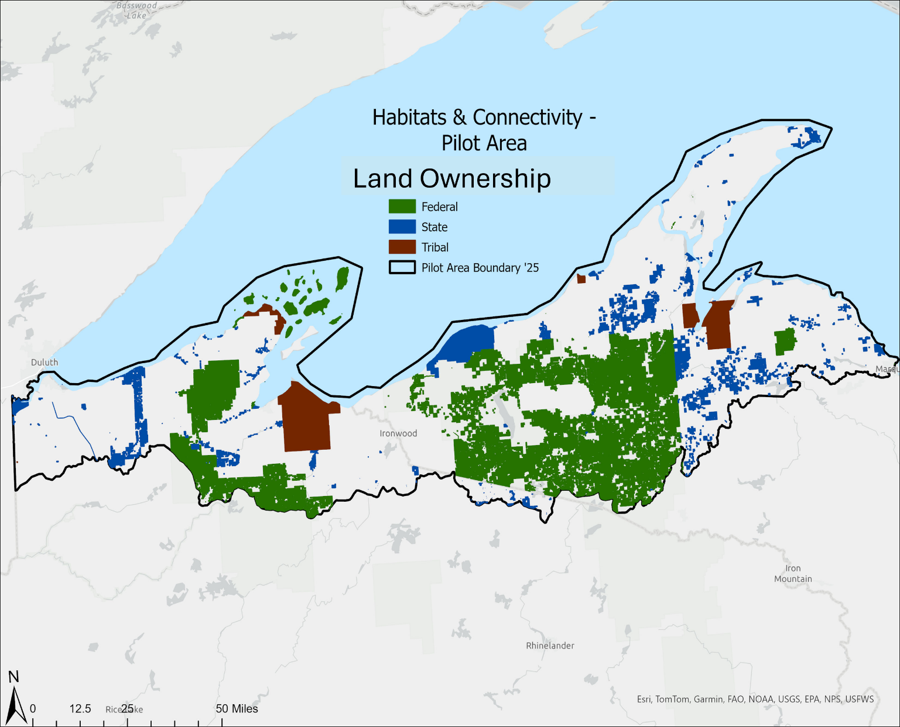
Figure 1. — Ownership within the Terrestrial Habitat Connectivity Pilot Area

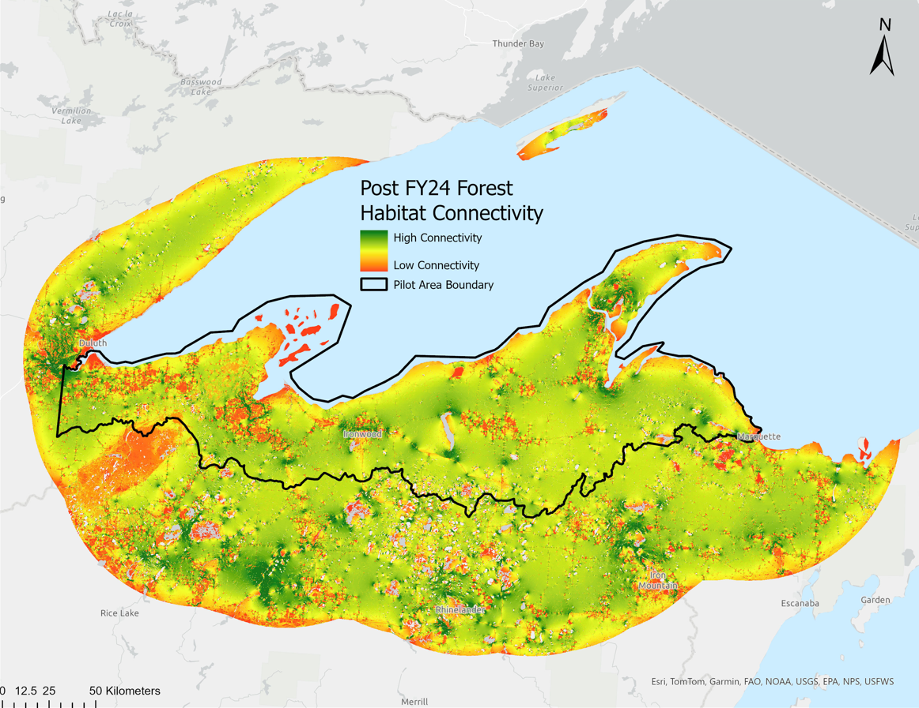
Figure 2. — Forest Habitat Connectivity within the Terrestrial Habitat Connectivity Pilot Area

Appendix B. Example Cover Page

2026 Great Lakes Restoration Initiative – Community Forest and Open Space Conservation Program Application

State Where Project is Located:
Project Name:
Applicant:
Type of Applicant:
Acres:
Total Project Cost:
CFP Funds Requested:

Appendix C. Sample Budget Tables

Estimated Project Costs
Cost Classification | Total Cost | CFP Cost (Federal) | Non-Federal Cost
Land Cost
Land Surveys
Appraisals and appraisal reviews
Legal and closing costs
Community Forest Plan Development
Title examination
Total Project Cost

Cost Share Budget Table
Funding Source | Federal | Non-Federal
CFP
(Enter Name of Organization)
(Enter Name of Organization)
Total
Explanation of Cost-share:

Lands acquired by Tribes through the Community Forest Program cannot be added into trust.

