Attachment 3:

PAS M&E performance monitoring plan (PMP)
Grantee Name:
program/project name:
Period of performance:
M&E budget amount:

Overview:

The M&E Performance Monitoring Plan (PMP) is a program management tool designed to measure progress towards the goals and objectives identified in the NOFO. The PMP also clarifies how and when the grantee will collect data on those indicators, the resources they intend to use for both program implementation and M&E. PAS recognizes that as part of your proposal and during the negotiation phase this document is likely to change, and as such, a work-in-progress. Please fill out both the narrative and PMP as detailed as possible.

If your proposal is accepted, this PMP must be approved by the PAS M&E specialist prior to finalizing your grants package.

M&E Narrative
Describe how the applicant plans to monitor and evaluate performance and outcomes (results) of the proposed project. Include key personnel, management structure for M&E activities, including methodologies used to demonstrate indicators (focus groups, surveys, etc.) any technologies (online surveys, social media analysis programs, etc.), and a budget narrative focusing only on M&E line expenditures listed in your program budget. This narrative should clearly show you have the capacity to implement the PMP you are proposing. Limit 3 pages.

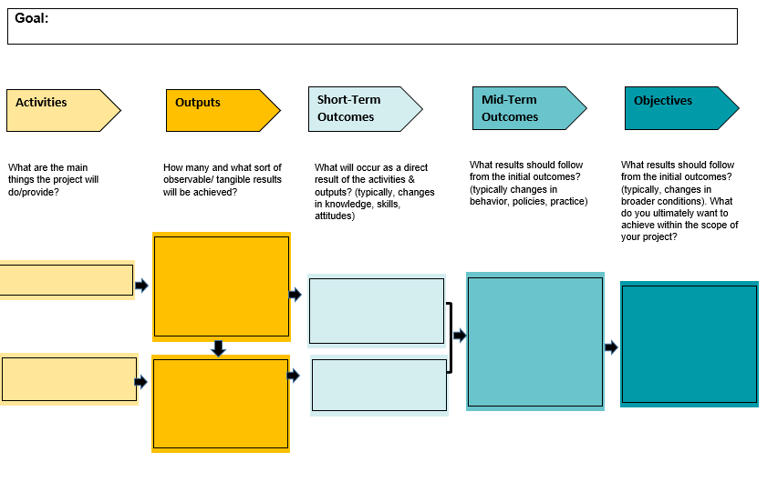
Theory of change
Include a theory of change statement: “If __________ are completed, then these outcomes (be specific) will result”? You may also include a Theory of Change diagram; A theory of change diagram is a type of logic model that explicitly illustrates the causal pathways between activities, outputs, outcomes, and objectives. There are many versions. An example includes:

M&E PMP datasheet:
Please fill in the below PMP. This document will be included in your quarterly reporting. See the “PMP Instructions” for guidance on filling in this datasheet.

Goal:
Audience:
Problem Statement:
Objective 1:
Activity | Indicator Description | Data Collection Method | Justification | Q?  Month-Month |  | Q?  Month-Month |  | Q?  Month-Month |  | Q?  Month-Month |  | Total of target | % of target achieved
 |  |  |  | Target | Actual | Target | Actual | Target | Actual | Target | Actual | Total of target | % of target achieved
 | Outcome 1.1:
 | Output 1.1.1:
 | Output 1.1.2:
 | Outcome 1.2:
 | Output 1.2.1:
 | Output 1.2.2:
 | Outcome 1.3:
 | Output 1.3.1:
 | Output 1.3.2:
Objective 2:
Activity | Indicator Description | Data Collection Method | Justification | Q?  Month-Month |  | Q?  Month-Month |  | Q?  Month-Month |  | Q?  Month-Month |  | Total | % of target achieved
 |  |  |  | Target | Actual | Target | Actual | Target | Actual | Target | Actual | Total | % of target achieved
 | Outcome 2.1:
 | Output 2.1.1:
 | Output 2.1.2:
 | Outcome 2.2:
 | Output 2.2.1:
 | Output 2.2.2:
 | Outcome 2.3:
 | Output 2.3.1:
 | Output 2.3.2:
Objective 3:
Activity | Indicator Description | Data Collection Method | Justification | Q?  Month-Month |  | Q?  Month-Month |  | Q?  Month-Month |  | Q?  Month-Month |  | Total | % of target achieved
 |  |  |  | Target | Actual | Target | Actual | Target | Actual | Target | Actual | Total | % of target achieved
 | Outcome 3.1:
 | Output 3.1.1:
 | Output 3.1.2:
 | Outcome 3.2:
 | Output 3.2.1:
 | Output 3.2.2:
 | Outcome 3.3:
 | Output 3.3.1:
 | Output 3.3.2:

