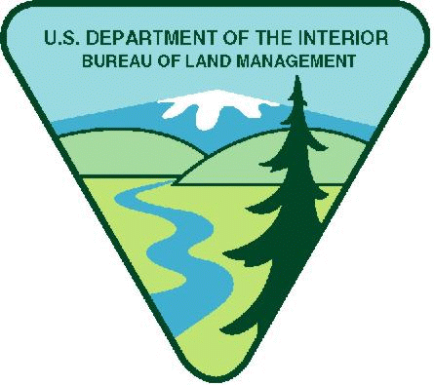
Project Title: OREGON: Prineville District Deschutes Field Office Youth Opportunity
Available Funding in FY25: $42,000.00
Maximum Funding (if multi-year): $210,000.00
Note: BLM has determined $800 weekly stipend equal to $20.00 per hour is reasonable. Stipends above this amount must justify in budget narrative increase needed.
Period of Performance: Date of award to September 30, 2029
Project Background Information: The Prineville District’s Deschutes Field Office (DFO) manages a diverse range of natural resources and recreation opportunities across Central Oregon. The field office manages a wide variety of landscapes from sage brush steppe to desert river canyons. DFO is continuously engaged in improving, expanding, and maintaining its recreation facilities while also improving and restoring habitats across the landscape.
Project Objective/Expected Project Outcomes: BLM Prineville District’s Deschutes Field Office has an opportunity to introduce local youth to natural resource and recreation management careers in the BLM, with a specific focus in recreation maintenance and habitat restoration. The Deschutes Field Office has resource specialists who would like to provide work experience to local Central Oregon youth for their career and educational benefit. This would be accomplished by providing local youth opportunities to gain hands-on experience, learn about and further their understanding of public lands, and pique their interest in conservation, restoration and recreation careers.
This opportunity will be focused on implementing restoration and conservation activities such as removing and rebuilding fences, installing flight diverters in sage grouse habitat, and stream restoration projects throughout the field office. This opportunity also focuses on recreation management projects such as constructing and maintaining recreation infrastructure including fences, tent pads, picnic tables and trails as well as vegetation management at recreation sites.
Work Schedule: Monday – Friday, generally 8 AM to 5 PM. Work may occur year-round and would likely be scheduled one week at a time, roughly. Overall scheduling will be determined by availability of both youth crew and BLM staff.

Knowledge Required by the Position: This opportunity will require time outdoors and field work that is often under somewhat rigorous physical conditions and challenging weather conditions. Chainsaw certifications and Oregon Pesticide Applicators License are helpful but not required.

Physical Demands: Most projects will involve moderate to arduous physical activity in an outdoor environment. Most projects may require crew members to hike with a load, lift and carry heavy objects, and use hand and power tools.

Work Environment: The majority of projects will take place outdoors in all types of weather conditions. Temperatures in central Oregon can range from summer highs in the 90’s with winter daytime highs in the 20’s. Projects could take place in all types of terrain including steep, rocky desert canyons, relatively flat juniper woodlands and in riparian zones next to rivers and streams.

Housing: Housing is not being offered. Overnight camping trips may be required. A bunkhouse may be available during project work in the Maupin area while projects in other areas may require camping. The majority of the projects will not require camping.

Vehicle Needs: Youth Corps organizations will need to provide for all transportation of crews. Some project sites are accessible via 2-wheel drive vehicles, but 4-wheel drive vehicles are required at many locations. Driving on pavement, gravel and native surface roads will be a common occurrence.

Other Project Considerations:

BLM will provide project planning, all materials and supplies, and specialized tools. Specific tool needs will be determined for each project. Crews are responsible for providing all Personal Protective Equipment (PPE), and basic tools such as shovels, hand saws and rakes. Crews are also responsible for providing their own food and water. Any specialized training required to complete a project will be provided by the BLM. Some projects may require overnight camping or staying in bunkhouses at BLM facilities.

Duties: The youth crew will assist the Prineville District’s Deschutes Field Office with implementing their on-the-ground recreation, habitat and conservation activities. Projects can include recreation infrastructure projects such as repairing fence, installing picnic tables and trail rehabilitation, or vegetative management projects at recreation sites such as pruning trees in campgrounds, weed whacking campsites, and applying herbicide at recreation sites. Other potential projects include habitat and conservation projects such as installing flight diverters in sage grouse habitat, retrofitting fences in mule deer winter range, or planting vegetation in riparian areas.

Project expected outcomes include six work weeks for a crew of 10 (approximately 2,100 hours). Specific expected outcomes will be project specific and could include miles of fence, number of tables, linear feet of roads/trails/streams treated.

BLM’s Substantial Involvement: There will be substantive BLM programmatic involvement by BLM professional to include mentoring, oversight, and engagement with youth participants as appropriate. BLM will have the right to intervene by modifying the project management plan, if project is not staying on schedule, technical issues arise, etc. In addition, BLM and recipient will meet weekly to discuss progress and track project outcomes; review any training needs; and then make a decision what direction to take in finalizing project or move to the next phase.

BLM Program Contact:
Jim Mueller
541-966-2003
J2muelle@blm.gov

Applicants are encouraged to refer to the full program announcement number L25AS00059 posted on Grants.gov for all program requirements and applicable terms and conditions. Recipients selected for awards will be required to adhere to those requirements should an award be made.

