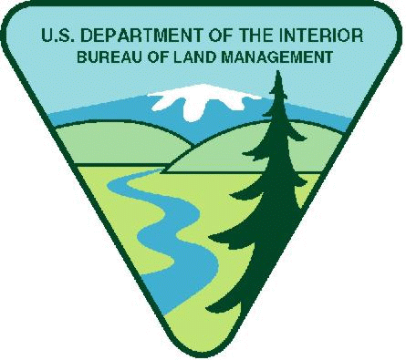
Project Title: OREGON- Wildwood Recreation Site Maintenance Youth Opportunity
Available Funding in FY25: $35,000.00
Maximum Funding (if multi-year): $45,000
Note: BLM has determined $800 weekly stipend equal to $20.00 per hour is reasonable. Stipends above this amount must justify in budget narrative increase needed.
Period of Performance: 06/01/2025-09/30/2026
Project Background Information: The Wildwood Recreation Site is located along the Mount Hood Scenic Byway near the town of Welches, Oregon. Mount Hood, Oregon's tallest mountain, beckons travelers through a forested corridor to wade the waters of the Wild and Scenic Salmon River that runs through this recreation site. This year-round day-use area is home to a wide range of recreation facilities and the Cascade Streamwatch Trail. Visitors have a chance to explore natural stream and wetland ecosystems along accessible interpretive trails and boardwalks and observe native fish in a unique underwater fish viewing chamber.
Project Objective/Expected Project Outcomes: BLM’s Cascades Field Office has an opportunity to introduce youth to careers in the BLM and to recreation and wilderness management. The Field Office recreation specialists will help provide mentorship and work experience to youth for their career and educational benefit. This will be accomplished by providing opportunities to gain experience, learn about public lands, further their understanding and appreciation of recreation and wilderness resources, and pique youth’s interest in managing public lands. This aims to increase appreciation and understanding of our public lands and become life-long stewards. This opportunity will focus on trail maintenance and resource protection. This project would be especially appropriate for a student studying recreation or natural resource management and will provide opportunities to enhance basic career skills such as organization, writing, detail, and communication. Youth will also learn field skills including the use of GPS equipment and maps, field note methods, and how to do trail construction and maintenance. Previous experience with any, or all, of these skills would significantly enhance the student experience but is not required.
Work Schedule: Monday – Friday, generally 8 AM to 5PM, for 3 weeks, with flexible start/end dates in from June to Sept.

Knowledge Required by the Position: This opportunity is suitable for youth working towards an undergraduate or graduate degree in natural resources or recreation management. As stated in the duties, this opportunity will require time outdoors and field work that is often under somewhat rigorous physical conditions.

Physical Demands: Much of the work is physical, requiring bending, stooping, and lifting. Good physical condition is essential to successful completion of the required tasks, such as trail work, recreation site maintenance, and vegetation management. Workers may use light power tools such as leaf blowers and power drills, or hand tools such as shovels, hoes, Pulaskis, McLeods, and rakes.

Work Environment: Work takes place outside, typically at Wildwood Recreation site, a front country developed recreation site, with good cell phone coverage and easy access to nearby communities and emergency care. Conditions are highly variable, but work typically occurs in the summer, where heat is the biggest concern. The site is forested, with a stream nearby. Worker safety is paramount, so supervisors will emphasize staying hydrated and well fed, with frequent breaks, especially when it’s hot.

Housing: Agency cannot provide housing but may be able to assist in locating appropriate clean housing.

Vehicle Needs: A personal vehicle is NOT required for the position but is strongly encouraged as it makes the applicant's days off much more enjoyable. The closest regional airport is in Portland, Oregon, less than an hour away.

Other Project Considerations:

Food: Youth Corps will provide food for crews while working at the site.

All Supplies: Youth Corps provides all tools. This includes trail maintenance equipment specific to Wilderness. This includes shovels, pulaskis, Mcleods, leaf blowers and rakes.

Training Requirements: Youth Corps will provide a youth corps leader who will conduct training for all tool use.

Travel: Youth Corps will provide a van to transport youth crews to the site.

Duties: The successful youth applicant will assist the BLM by maintaining the facilities of the Wildwood Recreation Site. Field work includes trail maintenance such as clearing brush, replacing damaged trail features, day use site maintenance, removing down trees, and maintaining a boardwalk.

Field work will be conducted at the Wildwood Recreation Site.

Weather and terrain conditions may be extreme (e.g., heat, cold, rain).

BLM’s Substantial Involvement: There will be substantive BLM programmatic involvement by BLM professional to include mentoring, oversight, and engagement with youth participants as appropriate. BLM will have the right to intervene by modifying the project management plan, if project is not staying on schedule, technical issues arise, etc. In addition, BLM and recipient will meet weekly to discuss progress and track project outcomes; review any training needs; and then make a decision what direction to take in finalizing project or move to the next phase.

BLM Program Contact:
Dean Reese
541-589-2248
wreese@blm.gov

Applicants are encouraged to refer to the full program announcement number L25AS00059 posted on Grants.gov for all program requirements and applicable terms and conditions. Recipients selected for awards will be required to adhere to those requirements should an award be made.

