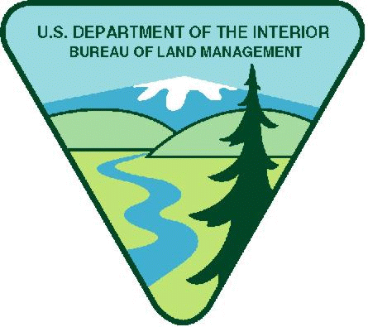
Project Title: OREGON: Siuslaw & Upper Willamette Weeds, Trails and BLM Site Maintenance Youth Opportunity
Available Funding in FY25: $25,000.00
Maximum Funding (if multi-year): $80,000.00
Note: BLM has determined $800 weekly stipend equal to $20.00 per hour is reasonable. Stipends above this amount must justify in budget narrative increase needed.
Period of Performance: August 1, 2025 – September 30, 2029

Project Background Information: Youth crews are vital to completing priority recreation and restoration projects in Northwest Oregon’s Siuslaw and Upper Willamette field offices. These projects ensure public access and help offer a positive visitor experience while also maintaining the health of public lands from invasive weeds. Work sites are within an hour of the cities of Eugene and Springfield, within the Siuslaw and Upper Willamette resource areas. The land base includes mostly timber lands managed for timber production and restoration but also includes Areas of Critical Concern (special habitat areas), developed campgrounds, day-use areas and adjacent hiking trails, swimming and boating areas, a 19-mile mountain biking trail system, and the West Eugene Wetlands. The West Eugene Wetlands contain interpretive nature trails and boardwalks, a paved bike path, and a disc golf course.
Project Objective/Expected Project Outcomes: The Siuslaw and Upper Willamette Field Offices will provide an opportunity to introduce youth to careers in outdoor recreation, natural resource management, and public lands management, and to allow youth to help the BLM accomplish priority restoration and recreation maintenance work that benefits public lands. BLM specialists in botany, ecology and recreation will guide the youth crews in completing the work, as well as provide insights into resource management and career opportunities.

Work Schedule: Youth crews will generally work Monday – Friday, 8:00 AM to 4:30 PM. Other schedules will be considered, and flexible schedules will be viewed favorably. Work will take place year-round, with the bulk of the work happening in the summer. The successful applicant will be comfortable working in a dynamic environment where scheduling will take place on a month-by-month basis.

Knowledge Required by the Position: This opportunity is suitable for organizations that have experience recruiting for and managing youth work crews. Familiarity with both native and invasive plants is preferred, as well as basic trail maintenance and carpentry skills.

Physical Demands: Members of the youth work crews must be able to work in outdoor conditions and have the basic skills and abilities to complete routine restoration and maintenance work, such as weed pulling, painting, trash pick-up, data collection, and trail brushing, repair and rebuilding. Crews should be skilled, or be easily and safely trained, in the use of hand tools such as loppers, weed wrenches, hand saws, pry bars, shovels, picks, hoes, rakes, post hole diggers, McLeods and wheelbarrows.

Work Environment: Work will occur outdoors at BLM recreation sites and trails as well as off-trail work in forest, meadow and/or riparian restoration sites. Work will often occur in remote locations without cell service, and in weather conditions common in the Willamette Valley, Cascade foothills and Coast Range, including frequent rain and wind in the spring, fall, and winter, and intense heat and sun in the summer.

Housing: Housing will not be provided.

Vehicle Needs: The applicant is required to provide transportation for the youth crew members to and from the work locations, which can vary depending on the project. This transportation must be able to handle gravel, dirt, and the occasional primitive road conditions.

Other Project Considerations: Food/Supplies/Training Requirements/Travel

Food: The applicant is required to supply youth crew members with all food and living supplies.

All Supplies: The applicant is required to provide the youth crews with basic living supplies and work tools. Specialized tools may be available from the BLM for certain projects on a limited basis.

Training Requirements: The applicant is required to provide youth crew members with the appropriate training to complete the work outlined in this opportunity, including, but not limited to, safe tool use and operation, first aid, and crew lead training.

Travel: The applicant is required to provide transportation for the youth crew members to and from the work locations, which may total up to 150 miles each day.

Duties: The successful youth corps applicant may assist the BLM with projects including, but not limited to, the following:
- Treat and/or remove invasive plant species including Scotch broom, invasive blackberries and false brome at recreation and restoration sites and along trails.
- Remove downed trees and storm debris, paint restroom buildings, maintain campsites including tent pads, picnic tables, fire rings, etc.
- Maintain, brush and spread mulch and gravel along trails.
- Assist BLM staff with basic data collection on the presence of rare plant species.
- Post, repair and replace damaged or missing trail and campground signage.
- Repair and re-route existing trails and bridges and construct new trails or trail segments and bridges.

BLM specialists will typically meet with crews in the field on the first day of a new project to ensure proper orientation and a good start to individual projects. Crews will generally work independently on each project after the initial day of orientation.
BLM’s Substantial Involvement: There will be substantive BLM programmatic involvement by BLM professionals to include mentoring, oversight, and engagement with youth participants as appropriate. BLM will have the right to intervene by modifying the project management plan, if project is not staying on schedule, technical issues arise, etc. In addition, BLM and recipient will meet weekly to discuss progress and track project outcomes; review any training needs; and then decide what direction to take in finalizing the project or how to move to the next phase.

BLM Program Contact:
Andrea Lawrence
Desk: (541) 683-6457
Cell: (458) 209-4378
alawrence@blm.gov

Applicants are encouraged to refer to the full program announcement number L25AS00059 posted on Grants.gov for all program requirements and applicable terms and conditions. Recipients selected for awards will be required to adhere to those requirements should an award be made.

