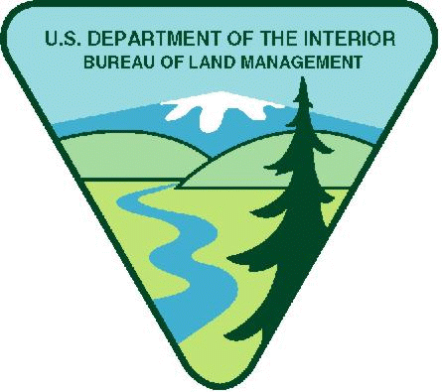
Project Title: OREGON- Northwest Oregon District Native Plant Restoration and Conservation Youth Opportunity
Available Funding in FY25: $20,000.00
Maximum Funding (if multi-year): $80,000.00

Note: BLM has determined that an hourly wage of at least Oregon’s minimum wage (currently $14.70) and at most $20.00 per hour is reasonable. Stipends above this amount must be justified in the budget narrative why the increase needed.

Period of Performance: 8/4/2025 - 9/30/2029
Project Background Information: Native plant communities are impacted by the introduction of invasive plant species, change in habitat conditions, urban or rural development, recreational use, or ground disturbing projects. Through restoration and conservation efforts, the Northwest Oregon District botany program is responsible for managing native plant communities, with particular focus on special status species and sensitive habitats such as prairies, oak woodlands, and riparian habitats.
Project Objective/Expected Project Outcomes: The Northwest Oregon District BLM botany program will introduce youth to natural resource careers within the BLM, with specific focus on restoration and conservation projects within the Siuslaw and Upper Willamette Field Offices. Youth will learn habitat restoration and conservation principles, while gaining hands on experience through implementation of planting monitoring, conifer removal, invasive plant management, and/or native plant augmentation.

Work Schedule: Monday – Friday, generally 8 AM to 5PM, individual workdays or work weeks will be scattered throughout the year as project needs arise, with particular need in late spring and summer months. No overnight camping is expected.

Knowledge Required by the Position: Interested partners must consist of youth corps, including a crew lead familiar with local flora and common noxious weeds.

Physical Demands:
Ability to traverse uneven terrain up to 1/2 mile each way; stand or walk for extended periods of time, push, pull, lift, or carry heavy equipment, tools, or supplies that weigh up to 25lbs; and stoop and bend repetitively for up to 8 hours.

Work Environment:
Field work may be conducted throughout the Upper Willamette and Siuslaw Field Office. Works sites could include forest habitats, wetlands, ridge meadows, roadways, or streams. Work will include navigating uneven terrain through a variety of climatic conditions including heat, cold, rain, and fog.

Housing: Agency cannot provide housing.

Vehicle Needs: Youth Corps must provide their own transportation to work sites. Vehicles must be capable of transporting tools, equipment, and personal gear. Commute time to work sites is generally about an hour, though longer commutes may be required. 4-wheel drive vehicles are advised as project locations are often accessed from gravel or native surface logging roads.

Other Project Considerations:

Food: All food for the youth corps must be provided by the project partner.

Tools and Supplies: All tools and supplies for weed eradication must be provided by the partner such as: weed wrenches, loppers, weed whackers, shovels, gloves, trash bags, etc. For all seeding and/or planting projects, the BLM will provide native plant materials.

Training Requirements: The youth corps is required to provide and train at least one crew lead who always remains with the youth crew. Training will include first aid/CPR. General weed identification skills and knowledge of local flora are preferred. The BLM will provide project specific training, such as special status species identification or weed treatment techniques or planting/seeding methods.

Travel: No overnight travel is required for this project.

Duties: Youth corps will assist BLM staff within the Upper Willamette and Siuslaw field offices. Specific duties include manual removal of encroaching vegetation or invasive species by hand, weed wrenching, lopping, or grubbing. Mechanical removal includes the use of weedwhackers with string or metal heads, chainsaw, or other brush cutters. Native plant augmentation includes seeding and or planting of plug, potted, or bare root plants. Monitoring activities could include conducting inventories, health and vigor assessments of target plant species, or conducting effectiveness monitoring of projects.

Project expected outcomes with FY25 funds include 30 acres of restoration activities including conifer removal, shrub/forb planting, plant monitoring, and invasive plant treatments, such as mechanical, manual, and/or competitive seeding. Lifetime project expected outcomes include 120 acres of restoration activities described above.

BLM’s Substantial Involvement: There will be substantive BLM programmatic involvement by BLM professional to include mentoring, oversight, and engagement with youth participants as appropriate. BLM will have the right to intervene by modifying the project management plan, if project is not staying on schedule, technical issues arise, etc. In addition, BLM and recipient will meet weekly to discuss progress and track project outcomes; review any training needs; and then make a decision what direction to take in finalizing project or move to the next phase.

BLM Program Contact:
Emily Erickson
541-683-6600
eerickson@blm.gov
Applicants are encouraged to refer to the full program announcement number L25AS00059 posted on Grants.gov for all program requirements and applicable terms and conditions. Recipients selected for awards will be required to adhere to those requirements should an award be made.

