# **Attachment 1:**

# **PAS M&E performance monitoring plan (PMP)**

**Grantee Name:**

**program/project name:**

**Period of performance:**

**M&E budget amount:**

**Overview:**

The M&E Performance Monitoring Plan (PMP) is a program management tool designed to measure progress towards the goals and objectives identified in the NOFO. The PMP also clarifies how and when the grantee will collect data on those indicators, the resources they intend to use for both program implementation and M&E. PAS recognizes that this document is likely to change over the life of the project, and as such, it will be a work-in-progress. Please be as detailed as possible when filling out the PMP.

***If your proposal is accepted, this PMP must be approved by the PAS M&E specialist prior to finalizing your grants package.***

## M&E Narrative

*Describe how the applicant plans to monitor and evaluate performance and outcomes (results) of the proposed project. Include key personnel, proposed management structure for M&E activities, and describe any methodologies used to capture indicators (e.g. focus groups, surveys, etc.), as well as any technologies used (e.g. online surveys, social media analysis programs, etc.). The narrative should also clearly describe M&E expenditures listed in your program budget. Further, the narrative should demonstrate the organization’s capacity to implement the PMP proposed. Limit two pages.*

## Theory of change

*To demonstrate that your project is measurable by design, please include the intended theory of change. This can be done with one, or a series of If-Then statements: “If __________ are completed, then these outcomes (be specific) will result in __________.” The theory of change may also be demonstrated with a Theory of Change diagram. A theory of change diagram is a type of logic model that explicitly illustrates the causal pathways between activities, outputs, outcomes, and objectives.* *There are many versions.* *An example includes:*

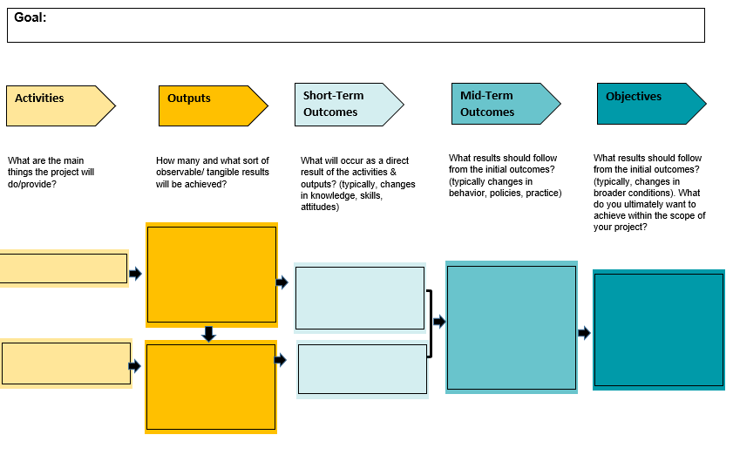

|  |  |  |  |  |  |  |  |  |  |  |  |  |  |  |
| --- | --- | --- | --- | --- | --- | --- | --- | --- | --- | --- | --- | --- | --- | --- |
| M&E PMP datasheet:  *Please fill in the below PMP. This document will be included in your quarterly reporting. See the “PMP Instructions” for guidance on filling in this datasheet.* | | | | | | | | | | | | | | |
| Goal: | | | | | | | | | | | | | | |
| Audience: | | | | | | | | | | | | | | |
| Problem Statement: | | | | | | | | | | | | | | |
| Objective 1: | | | | | | | | | | | | | | |
| Activity | Indicator Description | Data Collection Method | Justification | Q?  Month-Month | | Q?  Month-Month | | Q?  Month-Month | | Q?  Month-Month | | Total of target | % of target achieved |
| Target | Actual | Target | Actual | Target | Actual | Target | Actual |
|  | Outcome 1.1: |  |  |  |  |  |  |  |  |  |  |  |  |
| Output 1.1.1: |  |  |  |  |  |  |  |  |  |  |  |  |
| Output 1.1.2: |  |  |  |  |  |  |  |  |  |  |  |  |
|  | Outcome 1.2: |  |  |  |  |  |  |  |  |  |  |  |  |
| Output 1.2.1: |  |  |  |  |  |  |  |  |  |  |  |  |
| Output 1.2.2: |  |  |  |  |  |  |  |  |  |  |  |  |
|  | Outcome 1.3: |  |  |  |  |  |  |  |  |  |  |  |  |
| Output 1.3.1: |  |  |  |  |  |  |  |  |  |  |  |  |
| Output 1.3.2: |  |  |  |  |  |  |  |  |  |  |  |  |
| Objective 2: | | | | | | | | | | | | | | |
| Activity | Indicator Description | Data Collection Method | Justification | Q?  Month-Month | | Q?  Month-Month | | Q?  Month-Month | | Q?  Month-Month | | Total | % of target achieved |
| Target | Actual | Target | Actual | Target | Actual | Target | Actual |
|  | Outcome 2.1: |  |  |  |  |  |  |  |  |  |  |  |  |
| Output 2.1.1: |  |  |  |  |  |  |  |  |  |  |  |  |
| Output 2.1.2: |  |  |  |  |  |  |  |  |  |  |  |  |
|  | Outcome 2.2: |  |  |  |  |  |  |  |  |  |  |  |  |
| Output 2.2.1: |  |  |  |  |  |  |  |  |  |  |  |  |
| Output 2.2.2: |  |  |  |  |  |  |  |  |  |  |  |  |
|  | Outcome 2.3: |  |  |  |  |  |  |  |  |  |  |  |  |
| Output 2.3.1: |  |  |  |  |  |  |  |  |  |  |  |  |
| Output 2.3.2: |  |  |  |  |  |  |  |  |  |  |  |  |
| Objective 3: | | | | | | | | | | | | | | |
| Activity | Indicator Description | Data Collection Method | Justification | Q?  Month-Month | | Q?  Month-Month | | Q?  Month-Month | | Q?  Month-Month | | Total | % of target achieved |
| Target | Actual | Target | Actual | Target | Actual | Target | Actual |
|  | Outcome 3.1: |  |  |  |  |  |  |  |  |  |  |  |  |
| Output 3.1.1: |  |  |  |  |  |  |  |  |  |  |  |  |
| Output 3.1.2: |  |  |  |  |  |  |  |  |  |  |  |  |
|  | Outcome 3.2: |  |  |  |  |  |  |  |  |  |  |  |  |
| Output 3.2.1: |  |  |  |  |  |  |  |  |  |  |  |  |
| Output 3.2.2: |  |  |  |  |  |  |  |  |  |  |  |  |
|  | Outcome 3.3: |  |  |  |  |  |  |  |  |  |  |  |  |
| Output 3.3.1: |  |  |  |  |  |  |  |  |  |  |  |  |
| Output 3.3.2: |  |  |  |  |  |  |  |  |  |  |  |  |