Annex A: Background and Supplemental Information

- Background

With a projected population of 227 million people, Nigeria is the most populated country in Africa and accounts for 50% of West Africa’s population. The fragmentation of Nigeria’s geographical, ethnic, and cultural identity lines is effectively balanced by the country’s federal structure and the strong emphasis of the federal government on representing ethnic and cultural identities by grouping the country into six geopolitical zones. With the current growth rate of 2.42 percent (2022), the United Nations projects that the population of Nigeria will reach about 401.31 million by the end of the year 2050. Nigeria has a land area of 923,770 km² (356,669 mi²) is bordered to the north by Niger, to the east by Chad and Cameroon, to the south by the Gulf of Guinea of the Atlantic Ocean, and to the west by Benin. The 2006 population census survey reported.

Demographically, Nigeria has a large youthful population, about 28.76 per cent of the total population is below the age of 15 years and 45.46 percent are between the ages of 15 -35 years. In 2018, the total fertility rate was 5.3 births per woman, crude birth rate was 38 live births per 1,000 women, and adolescent fertility rate was 107 live births per 1,000 women, while approximately 56.8 percent of pregnant women had 4 or more antenatal care visits within the 12-month period (NDHS, 2018). According to the same report, the use of any contraceptive methods by women currently married or in union (or their partner) was 16.6 per cent in 2018, of which only 12.0 per cent used modern methods, while 83.4 percent were not using any contraceptive methods. Only 29 percent of the infants under age six months were found to be exclusively breastfed, while only 42 per cent are put to breast within the first hour of birth. In addition, there is a 22 percent malaria prevalence among children under five years (MIS 2021).

Nigeria is undertaking a range of ambitious health sector programs to improve financial risk protection, advance access to quality primary health care services and increase quality and coverage of health service delivery. The Government of Nigeria, through the Federal Ministry of Health and social welfare has committed to the operationalization of the Sector Wide approach (SWAp) for Nigeria’s Health Sector Renewal Investment Program (NHSRIP), hence pursuing increased access to quality health care services, particularly among rural, vulnerable populations. It has also proposed redesigning the Basic Health Care Provision Fund (BHCPF), established by NHA 2014, to become more effective and efficient in driving the strategic shifts and priority initiatives. The SWap is envisioned to apply sector-wide policies to an expenditure framework and national implementation systems; explicit health sector reforms that will be undertaken to meet sectoral and national development objectives. In the last decades, the United States has been a steadfast partner in strengthening Nigeria’s health sector. U.S. health investments and partnerships in Nigeria – such as the U.S. President’s Emergency Plan for AIDS Relief (PEPFAR), the U.S. President’s Malaria Initiative (PMI), and global health security intensive support partnership program have saved millions of lives, strengthened health systems, and USAID/Nigeria envisions a world where all women, newborns, and children survive and are healthy and able to reach their full potential, contributing to the development of their communities and countries..

A). The Health Sector
With an annual population growth rate estimated at 2.4%, the population is projected to increase to over 377 million by 2050. Many of the health problems of women and children are related to high fertility, with an average of 5.3 births per woman in 2018 (NDHS, 2018). 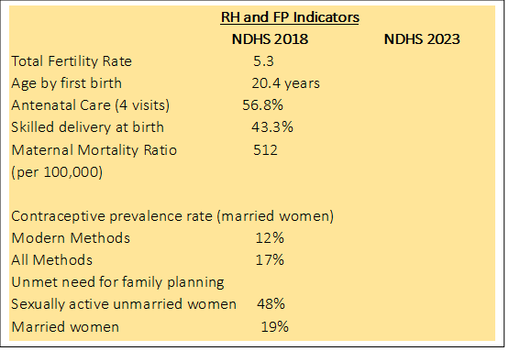
In addition, almost half of the total population (45%) is between the ages of 15-35. A young population, combined with high fertility, limited access to FP, and low contraceptive usage not only predicts rapid population growth for at least another generation. The unmet need and seemingly high demand for family planning (compared with available/accessible services) is an important low hanging opportunity to increase access to and use of modern contraceptive methods. These trends will exacerbate Nigeria’s poor maternal health. Utilization of RH care services in Nigeria is low and varies substantially by women’s place of residence, educational level and religion. Nationwide, only 43.3% of women receive skill delivery at birth (NDHS, 2018). Early marriage is widely practiced, exposing young women to premature and prolonged childbearing and poor health outcomes. The majority of Nigerians (54 percent) access FP services through the public sector. The preferred family planning methods in Nigeria continue to be highly skewed towards short-term methods, in particular oral contraceptives (OCs). Supply-side factors that contribute to the skewed method mix include inadequately equipped facilities and insufficiently skilled personnel to provide long acting methods. Other factors such as limited time for provider-client interactions, heavy workload, and provider biases also contribute to the skewed method mix. Many primary health care facilities lack providers with the skills to offer integrated FP services, especially in remote, underserved areas. Post-delivery and post-abortion FP are significant service delivery gaps. In Nigeria, abortion is legally restricted and complications from unsafe abortions are a major public health concern. Provisions for life saving post abortion care—for women who experience incomplete spontaneous abortion as well as those who have unsafe abortions—at primary care facilities are often absent, and women are generally referred to secondary and tertiary hospitals, for life saving health care. There is a need to build the capacity of health workers to ensure that they are able to provide the full package of post-abortion care and refer women for other services when necessary.
Although the national maternal mortality ratio (MMR) has declined by 11 percent from 576 per 100,000 live births in 2013 to 512 per 100,000 live births in 2018, it remains unacceptably high—well short of the Sustainable Development Goals (SDG) target of less than 70 per 100,000 live births. The major direct causes of maternal deaths in the country as reported by the institute of health metrics and evaluation were Haemorrhage (24%), Preeclampsia/Eclampsia (17%), Sepsis (15%), Unsafe abortion (13%), Obstructed labor (8%), and Others (23%). The indirect causes are Malaria (11%), Anaemia (11%) and others like sexually transmitted infections (STIs) including HIV/AIDS, Diabetes Mellitus etc. (5%).
The Nigerian government has taken several efforts to improve the reproductive health status of women. The safe motherhood and family planning division at the MOH have put in place an enabling environment for the development and implementation of several policies, strategies and action toward meeting the development objectives of the country and have called for the expansion of these critical services. The National RH Strategy, which is currently being revised outlines key issues, goals, strategies and actions to improve RH in the country.
Nigeria is among the top five countries in the world with the highest under-five mortality rates. NDHS 2018 showed a 3 percent decline in neonatal deaths in 28 years. Comparison of neonatal deaths’ reduction trend from the National Demographic and Health Survey showed that in 1990 (42 per cent), NDHS 2003 (48 per cent) NDHS 2008 (40 per cent), NDHS 2013 (37 per cent) to the latest edition of the survey — NDHS 2018 (39 per cent) showed only three percent neonatal deaths’ reduction in the country from 1990 till 2018. Nigeria remains the country with the highest number of under-five deaths in Africa and overtook India in the latest UNICEF report. According to data by the United Nations Children’s Fund, out of more than 2.5 million babies born dead globally each year, more than 400,000 stillborn deaths take place in Nigeria, Nigeria accounts for one of the highest stillbirth rates in the African continent. It is one of six countries that bears the burden of half of all stillbirths globally, with with 42.9 per 1,000 birth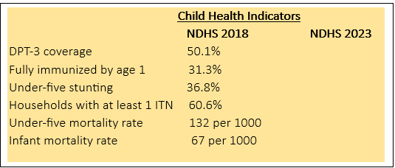
Leading causes of under-five death include preterm birth complications, birth trauma, pneumonia, congenital anomalies, diarrhea, and malaria. Over 70% of these deaths are preventable through access to and use of basic primary health care services. Infant and under-five mortality rates are closely related to key socioeconomic and geographic characteristics. Both rates decrease as household wealth index and the mother’s education level increase, while both rates are higher in rural areas and in the North-West geopolitical zone. A child from the poorest 20 percent of households is twice as likely to die before their first birthday or to die before their fifth birthday than a child from the wealthiest 20 percent of households. Disparities in full immunization have widened since 2007. Full immunization remains almost three times higher among urban children than among rural children. Children from the wealthiest 20 percent of households are 16 times more likely to be fully immunized than children from the poorest 20 percent of households. A child whose mother has a secondary or higher education is four times more likely to be fully immunized than a child whose mother has no education. Malaria diagnosis and treatment rates differ greatly according to a child’s socioeconomic background. An estimated 2 million children in Nigeria suffer from severe acute malnutrition, with 37 percent of children under 5 years stunted (NDHS, 2018). Around 70,000 children under the age of 5 die annually of diarrhea due to lack of access to clean water.
The Nigeria National Child Health Policy (NCHP) revised in 2022 provides direction for the growth and development of every child in Nigeria in line with global and national goals and targets and seeks to ensure that the “Health” in all policies are achieved in line with the commitment towards the Universal Health Coverage. The Child Survival Action Plan (CSAP) is currently being developed and will focus on the primary causes of mortality outlined above and will be grounded in an accelerated plan for the reduction of under-five mortality to 25/1000 by 2030.
Overall the quality of care at all levels remains poor or suboptimal, there is a weak community health program resulting in missed opportunities, and lack of continuum of care along the lifecycle of women and children and across service delivery levels. There are barriers that impede access to services, including user fees, geography, negative influence of religion, socio-cultural barriers on care seeking, insecurity, insufficient number of skilled personnel trained to provide health services, inadequately equipped facilities and other factors such as limited time for provider-client interactions, and heavy workload. These barriers contribute to the poor quality of services provided across public health facilities in Nigeria.
Organization of Health Care Delivery System and Coverage in Nigeria
All three tiers of government Federal, State, and Local share responsibilities for providing health services and programs in Nigeria. The Federal Government is largely responsible for providing policy guidance, planning, and technical assistance, and coordinating the state-level implementation of the national health policies, and establishing health management information systems. State Governments provide secondary level care while LGAs have responsibility for PHC services.

Nigeria has a growing private health sector which provides 60% of the health care servicesThis, this includes not-for-profit services provided by faith-based and non-governmental organizations; and private-for-profit providers. The broader private health sector also includes traditional medicine providers, patent and proprietary medicine vendors (PPMVs), drug shops, community pharmacies, and complementary and alternative health practitioners. The National Health Bill (2014) determines the standards and also regulates health service delivery in Nigeria, including for both private and public health providers

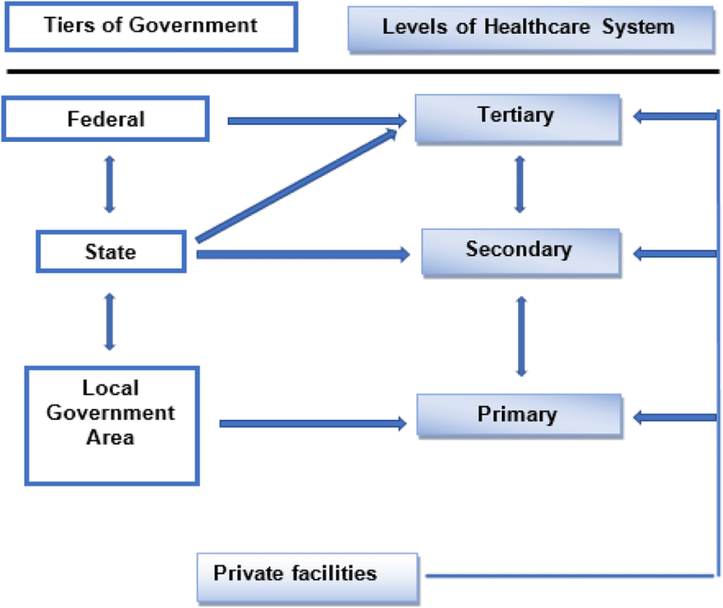
Fig 1. Levels of healthcare delivery in Nigeria
Table 1: Health facility type and coverage
Type of health facility | Level of care | Coverage (Minimum)
Tertiary hospitals | Tertiary | 1 per state
General Hospitals | Secondary | 1 per Local Government Area
Primary health centers | Primary | 1 per ward, an average of 10 wards per LGA
Primary health clinics | Primary | 1 per group of villages/neighborhoods with about 2000-5000 persons
Health posts | Primary | 1 per village neighborhood of about 500 person, as many as the number of villages
Source: Nigeria Ward Health System

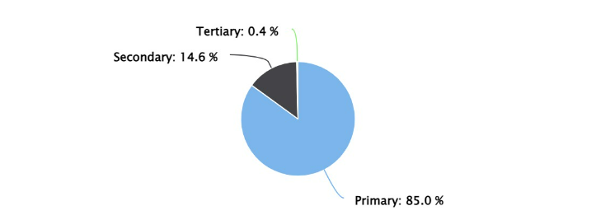
Fig 2. Percentage of hospital and clinics by level of care
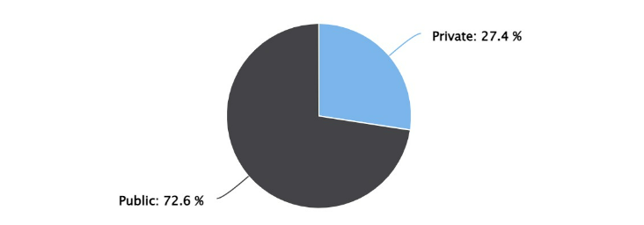
Fig 3. Percentage of hospital and clinics by ownership
In the last decade, Nigeria has made good progress in the health sector?through forward-looking reforms, including:
- “Primary Health Care Under One Roof” policy
- Community Health Influencers, Promoters and Service (CHIPS) policy
- National Private Sector Engagement Strategy on Sexual Reproductive Health
- Nigeria’s National Health Act 2014
- Basic Health Care Provision Fund

Overlaying these initiatives are the National Strategic Health Development Plan II (NSHDP II). The NSHDP II is anchored on the 2016 National Health Policy which recognizes Nigeria's aspiration to attain Universal Health Coverage by operationalizing the one functional Primary Health Clinic per ward. The NHSRIP will move this effort forward, by expanding access to quality health care services to additional 17,000 primary health care facilities across the county.

B). Building on Prior and current Investments
The PHIP activity will build on the current USAID supported programs which include the flagship bilateral integrated health programs and a variety of field support mechanisms that implement USAID-supported RH/FP, maternal and child health activities. The Mid-term evaluation report of the Integrated Health program (IHP) is included as an annex to this document. All USAID-supported activities are conducted within the context of the Nigeria Strategic Health Development Plan II (NSHDP II). .
Integrated Health Project: The five-year, $225 million Integrated Health Program (IHP) is implemented in Bauchi, Kebbi, Sokoto, Ebonyi and FCT. IHP contributes to revitalizing primary health care by supporting the state health systems and deploying an integrated model for a full complement of high-quality round-the-clock health services in every ward. Major intervention areas include:
- Health systems strengthening
- Maternal Health
- Newborn health
- Child health
- Reproductive health/family planning
- Nutrition
- Malaria
Breakthrough Action: This activity contributed to increasing the adoption and practice of priority health behaviors in the areas of malaria; maternal, newborn, and child health, including nutrition (MNCH+N); Family Planning (FP)/Reproductive Health (RH); and Tuberculosis (TB) among individuals, households and health care providers. BA also focused on increasing capacity of i) public sector (government MDAs) at national and state levels for SBC coordination and oversight and ii) community level health governance structures such as Ward Development Committees (WDCs), religious and traditional leaders

President’s Malaria Initiative for States: Contributes to the reduction of all causes of under-five and maternal mortality by delivering quality services for management of malaria and its complications and prevention of malaria during pregnancy and in children under five (CU5). Major interventions include:

- Malaria case management for uncomplicated and severe malaria including integrated community case management.
- Surveillance Monitoring and Evaluation (SME)
- Drug-based malaria prevention and treatment approaches
- Health system strengthening including planning, management, and supervision

MOMENTUM Safe Surgery in Family Planning and Obstetrics: Support the Government of Nigeria (GoN) in strengthening surgical safety within maternal health (MH) and voluntary family planning (FP) programs, by promoting evidence-based approaches and testing new innovations

Momentum (MCGL) GBV: Supports laws, policies, guidelines, and strategies that address four key technical priority areas: intimate partner violence (IPV), sexual violence (SV), child early and forced marriage (CEFM) and early adoption of family planning (FP).

Momentum MCGL QoC: Contributes to global technical leadership and learning, and USAID’s policy dialogue for achievement of global MNCH/FP/RH goals through support to globally endorsed MNCH/FP/RH initiatives, strategies, frameworks, guidelines, and action plans

UNICEF MNTE: Addresses the inequities in health care by adopting a high-risk approach that complements tetanus vaccination of pregnant women by immunizing women of reproductive age (WRA) through supplementary vaccination

MRITE: Builds the capacity of countries to identify and overcome barriers to reaching zero‐dose and under‐immunized children and older populations with life saving vaccines and other integrated health services

Core Group Polio Project (CGPP): Contributes to eradication of Polio and provide support to the Immunization System Strengthening in the five focal States of Borno, Kaduna, Kano, Katsina and Yobe States through community sensitization, mobilization and active case search of acute flaccid paralysis.

Promoting the Quality of Medicines Plus (PHIPM+): Sustainably strengthen medical product quality assurance systems in low- and middle-income countries, and build in-country capacity of medicines regulatory authorities and quality assurance systems in assisted countries

Health Resilience in Northeast Nigeria (HeRON): The activity aims to sustainably improve access to quality primary health care (PHC) and nutrition services by building the resilience of the health system in Borno and Yobe States, thereby contributing to better health outcomes of the populace.
Youth-Powered Ecosystem to Advance Urban Adolescent Health (YPE4AH): Improves health and well-being of urban, underprivileged, out-of-school, and unmarried adolescents aged 15–19 by increasing voluntary family planning (FP) uptake and continued use; leverage other resources for livelihood and entrepreneurship opportunities; and build capacity of local partners.

Health Workforce Management (HWM): Supports establishing a cost-effective, well-trained, and motivated health workforce in targeted rural and remote areas of Bauchi, Ebonyi, Kebbi, and Sokoto States and the Federal Capital Territory (FCT)

Advancing Nutrition in Nigeria: A flagship multisectoral nutrition activity with focus on improving access to quality health and nutrition services during the critical 1,000-day window between the start of a woman’s pregnancy and the child’s second birthday by layering interventions to strengthen the health system, food systems, and community resilience for sustainable nutritional outcomes.

Other Health Programs
The PHC/QoC activity will coordinate its activities, ensure technical and geographical alignment, and will be co-located with the following USAID supported programs and new designs.
- Community health and SBC Activity
- Health care finance and human resource for health Activity
- Digital health information Activity
- Supply chain Activity

C). Linkages to other USAID Programming
For many communities, health is one of several other challenges and needs. Where productive and feasible, the applicant will link with projects supported by other USAID/Nigeria offices for direct and indirect health benefits.

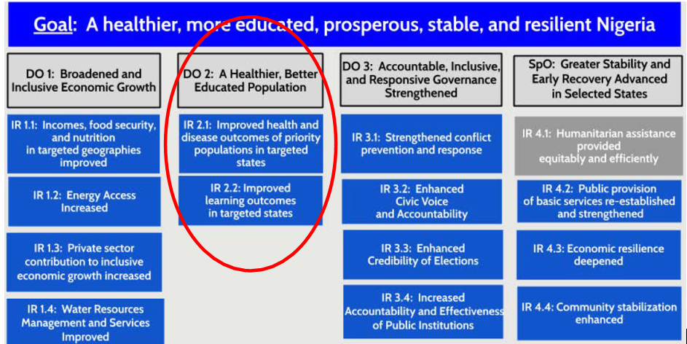
Fig 4. USAID/ Nigeria’s programming is guided by the 2020-2025 Country Development Cooperation Strategy (CDCS).
This PHC/QoC activity falls under DO2 and will play a key role in the achievement of the DO. It is designed to contribute to the attainment of Intermediate Result (IR) 2.1 Improved health and disease outcomes of priority populations in targeted states. This activity will complement other USAID supported activities in HIV/AIDS, nutrition, malaria and tuberculosis. As the pattern of morbidity and mortality is complex and interrelated, the high burden of HIV/AIDS, tuberculosis, and malaria greatly impact MNCH.
USAID supports a harmonized approach to health systems strengthening that cuts across the two IRs of DO2. This approach includes human resources for health, Health care finance, data use for decision-making, supply chain and logistics management, and implementation of policies and guidelines. Support to community health systems strengthening and strengthening the capacity for development of implementation policy and guidelines will also contribute to the Mission’s cross cutting themes of governance and engaging local leaders, this activity will be complementary to the other designs that will be co-located for better results and outcomes.
Furthermore, the PHIP activity has linkages to USAID/Nigeria’s other DOs given the focus of maternal, newborn and child health and family planning interventions. Where opportunities emerge, the RMNCH-Nutrition portfolio must actively coordinate and collaborate with other USAID partners to address the issues faced by common beneficiaries.

