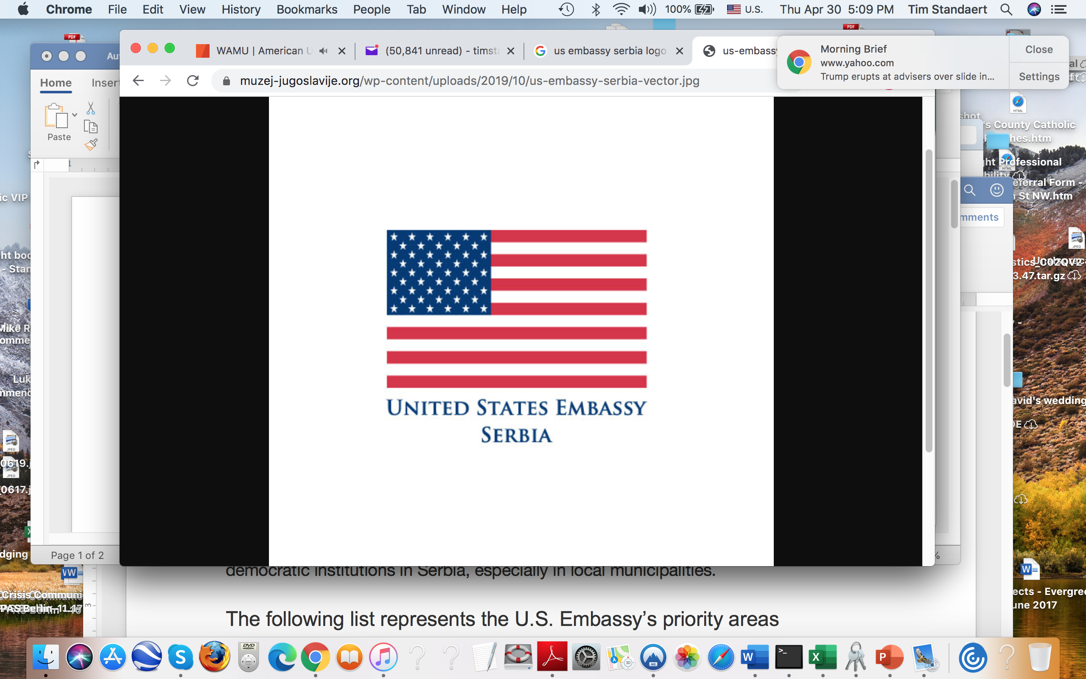
U.S. EMBASSY BELGRADE, SERBIA
Public Affairs Section (PAS)
SMALL GRANTS
APPLICATION FORM

FY2020

IMPORTANT: While filling out this form, please pay careful attention to all the instructions in the Notice of Funding Opportunity (NOFO) or the Annual Program Statement (APS). (The NOFOs and APS can be found at https://rs.usembassy.gov/education-culture/grants-programs.) If your application is incomplete, it will be considered technically ineligible and your project will not be considered for funding.

Date of Application. | , 2020

Grant Program Category. | SELECT ONE OF THE FOLLOWING: Alumni. English Language Program. Media Training & Development. Democracy Commission. University Partnership. Annual Program Statement.

Theme or Priority Area. | Necessary only if required in the NOFO.

Project Title in English. | (Max 200 characters.)

Project Title in Local Language. | (Max 200 characters.)

Name of Individual or Organization Submitting Application in Local Language. | ORGANIZATION: The name should match the one on file with the Agencija za privredne registre. INDIVIDUAL: If you are an alumnus, please also tell us which U.S. Government exchange program you participated in and when.

English Translation of Organization Name. (Optional)

DUNS Number. | Required only if the applicant is an organization.

Contact Information. | Name of person submitting this proposal, full mailing address, phone number, and email address.

Website and/or Social Media. | Your website address and social media account information.

Total Amount Requested (in dollars). | $  NOTE: The Basic Budget Breakdown below should clearly explain how you arrived at this figure. Don’t forget to attach the Detailed Budget spreadsheet, too!

Proposed or Anticipated Project Start and End Dates (if known). | Flexible start date? (Yes/No)  Anticipated start date:  Anticipated end date:  Total program length: (specify whether # is weeks or months.)  Please do build in time to assess the results or impact of the project.

PROJECT PROPOSAL

EXECUTIVE SUMMARY. THIS SECTION IS VERY, VERY IMPORTANT. The reader should be able to understand the project from reading the Executive Summary. (Max 1000 characters.)
Briefly and clearly explain the proposed project, including objectives, information on participants, description of activities, and anticipated impact and outcome. Feel free to provide a brief justification.

Problem Statement. (Max 1000 characters.)

Briefly explain the main problem or challenge this project addresses. Feel free to provide some basic background and/or appropriate links.

Overall Approach / Justification for Project. (Max 1000 characters.)
- What general approach are you taking to address that problem or challenge? Are you going to: provide training? run workshops? develop curriculum; provide mini-grants to participants? create a traveling exhibit or a website; set up an exchange program? host a conference (real or virtual)? organize an exhibition, performance, or other event? (Provide details under “Description of Activities.”)
- How will this approach help your community or society to address the problem or challenge you mentioned in the box above?
- What’s your justification for this approach and for this project? Why is this a good, effective way of solving the problem or challenge?

Intended Outcome/Impact.
- What is the outcome or impact you hope to have? NOTE: Your objectives should be specific and measurable. They should also be realistic. You should be able to complete them within the timeframe of the grant period.
- Are you trying to:
- promote awareness or educate others? If so, about what issue?
- shift attitudes? If so, on what issue and in what direction?
- generate action? If so, to address what problem or challenge? What type of action?
- strengthen the capacity of a group or organization? If so, which group/organization? In what area or field of activity? (Ex., strategic planning? communications? delivery of a service?)
- create or strengthen linkages? If so, between which groups or institutions?

Beneficiaries / Audience / Participants. (Max 1000 characters.)
- Who is the specific target audience for your project? People of a certain age, gender, profession? Students, civil society activists, officials, academics, young leaders, decision-makers? Members from disadvantaged or minority groups?
- In what cities, towns, or communities will the project take place? Why did you select these locations?
- How many participants, beneficiaries, or audience members will be involved?
- How will you choose the individuals who will take part in the project?
- Most importantly of all, why are you focusing on this group or these groups? How does this particular population help you in terms of the overall approach explained above? You can explain it this way: “If we are able to do X activity with Y group, we expect Z to happen.”

Description of Program Activities. (Max 2000 characters.)
What specific activities will take place during the course of your project? What is the project schedule or timeline? What are the “milestones” during the course of the project? (For example: We will have participants fill out a pre-activity survey on this date. We will hold workshops on X topic on this date and on Y topic on that date. We will set up a website on this date. By this date, the participants will have done X or been trained in Y. We will complete a follow-on/post-activity assessment or evaluation of the impact of our activities by this date.)

Measuring and Evaluating Outcome/Impact. (Max 1000 characters.)

How will you measure the “Intended Outcome/Impact” you mentioned above? Will you conduct “before” and “after” surveys of participants? Will you measure change in public opinion in a community? Will you (or an outside organization that you hire) conduct an assessment whether beneficiaries retain new skills or knowledge gained during the main grant activity? Will you track whether participants have taken certain actions in the weeks or months after the main project activity ends? Will you see if new courses are established at a school or new teaching methodologies adopted? Will you monitor is legislative hearings take place or new laws are passed?

NOTE: Please do remember to include time and costs into your planning of this project, including the timeline and the budget.

Long Term (Optional). (Max 1000 characters.)
After you have already measured your impact and submitted your final report to PAS:
- What further actions do you expect the participants or audiences will take in the weeks, months, or years that follow?
- What is the “multiplier effect” that could occur? (For example, could teacher who participate pass along a new skill to their students? Might a journalist write a story about a topic related to the project?)
- What longer-term impact do you think your project could have if it is successful?
- How might you yourself build on what you accomplish with this project? How might you yourself “scale up” the activity?
- What further activities might you recommend that governmental, educational, cultural, or other institutions take to expand upon your project idea?

BACKGROUND ON APPLICANT

Background on Applicant. Please provide a short introduction to the individual or description of the organization applying for grant funding. (Max 1000 characters.)

Key Personnel, Partners, and (if already known) Contractors. Provide the names and titles of team members, partners, and contractors. Make sure you also attach the required CVs.

Past (or Current) U.S. Embassy or U.S. Government Grants.
For each past U.S. Embassy or U.S. Government grant, please provide the following:
- project name, date of the grant activity, the amount of the grant, source of funding or program name (e.g., DemCom, Alumni).
- a short description of grant activities.
- links to your website and any media stories about the grant activity.
- grant activity results, impact of the project, and lessons learned.

What is your most compelling argument why your current project merits the receipt of additional funding from the U.S. Embassy, even at the expense of other activities by new partners?

Other Past or Current Activities.
For each past grant from other (non-US Government) donors or sources, please provide the following:
- project name, date of grant activity, the amount of grant.
- a short description of grant activities.
- links to your website and any media stories about the grant activity.
- grant activity results, impact of the project, and lessons learned.

What other past experience and/or current activities demonstrate your ability to carry out the proposed project?

BUDGET

BASIC BUDGET BREAKDOWN. This section is absolutely required! Again, please pay careful attention to all the instructions in the Notice of Funding Opportunity (NOFO) or Annual Program Statement (APS). You must show the calculations to explain how you arrived at the amount requested for each line.

Please also remember to attach a DETAILED BUDGET (in Excel spreadsheet format) to this application.

CATEGORY | DESCRIPTION + CALCULATION (i.e., number of units x cost per unit) | AMOUNT REQUESTED
Personnel |  | $
Fringe Benefits |  | $
Travel | e.g., Travel for participants (Vranje to Novi Sad): 2 bus tickets x $20/ticket = $40. Travel for participants (Belgrade to Novi Sad): 4 bus tickets x $12/ticket = $48. | $
Equipment Rental | e.g., Renting TV camera: 4 hours X $10/hour = $40. | $
Supplies |  | $
Contractual Services | e.g., Conference venue: 2 days X $50/day = $100. | $
Other Direct Costs |  | $
Indirect Costs |  | $
TOTAL REQUESTED |  | $
Cost Share |  | $
PROJECT TOTAL |  | $

Other Sources of Funding.
From what other donors or organizations are you seeking funding for this project? What is the name, phone number, and email address for the contact person at each organization? How much money are you seeking from them?

